## Lodgepole Pine (LPN)

**General Information**

**Cover Type Overview**

**Lodgepole Pine (LPN)**

* 2,161.01 acres / 874.53 hectares
* Crosswalk to EVeg: Regional Dominance Type 1
  + Lodgepole Pine
* Crosswalk to EVeg: Regional Dominance Type 2
  + Any
* Crosswalk to Presettlement Fire Regime Type
  + Lodgepole Pine
* Crosswalk to LandFire Biophysical Settings
  + 0610581 Sierra Nevada Subalpine Lodgepole Pine Forest and Woodland – Wet
  + 0610582 Sierra Nevada Subalpine Lodgepole Pine Forest and Woodland – Dry

**Lodgepole Pine with Aspen (LPN-ASP)**

* 19.57 acres / 7.92 hectares
* This type is created by overlaying the NRIS TERRA Inventory of Aspen on top of the EVeg layer. Where it intersects with LPN it is assigned to RFR-ASP.

**Vegetation Description**

**Lodgepole Pine (LPN)** *P. contorta* ssp. *murrayana* is the overwhelming dominant within its forest community, mixing occasionally with *Abies magnifica*, and with scattered *Pinus jeffreyi*  and *Pinus monticola*, and *Tsuga mertensiana* at higher elevations. The generally low stature and open stand structure of *P. contorta* ssp. *murrayana* forests is a function of these severe climate conditions and the thin, nutrient-poor soils that characterize this zone (Fites-Kaufman et al. 2007).

Mature Sierran stands often contain significant seedlings and saplings, in contrast to the even aged character of stands in the northern Cascades and Rocky Mountains. Understory characteristics are influenced by proximity to meadow and stream margins. *Arctostaphylos* and *Ribes* are common shrubs. Stands associated with meadow edges and streams may have a rich herbaceous layer consisting of grasses, forbs, and sedges, most notably *Cassiope mertensiana, Vaccinium caespitosum, Phyllodoce breweri*, and *Kalmia polifolia*, as well as *Ceanothus, Chrysolepis,* and *Carex*. Elsewhere, the understory may be virtually absent, consisting of scattered shrubs such as *Quercus vaccinifolia*, and herbs like *Antennaria, Arabis, Eriogonum,* and *Gayophytum.* Fast-moving streams are generally characterized by relatively dense populations of willows (*Salix* spp.) (Bartolome 1988, Fites-Kaufman et al. 2007, LandFire 2007a, LandFire 2007b).

**Lodgepole Pine with Aspen (LPN-ASP)** When *Populus tremuloides* co-occurs with LPN on the west side of the Sierran crest, it is typically found in smaller patches, often less than 2 ha (5 acres) in size. Mature stands in which *P. tremuloides* are still dominant are usually relatively open. Average canopy closures range from 60 to 100 percent in young and intermediate-aged stands and from 25 to 60 percent in mature stands. The open nature of the stands results in substantial light penetration to the ground (Verner 1998).

**Distribution**

**Lodgepole Pine (LPN)** Open stands of *P. contorta* ssp. *murrayana*, which make up a widespread upper montane forest/woodland, tolerating both rocky soils and semisaturated meadow edges, in an elevational belt within and above the *A. magnifica* zone. These forests, strongly dominated by *P. contorta* ssp. *murrayana*, generally occur at elevations of about 1,830 to 2,400 m (6000 to 7875 ft) in the northern Sierra Nevada. Stands of *P. contorta* ssp. *murrayana* may reach much lower, however, with cold air drainage down glacial canyons (Fites-Kaufman et al. 2007). On infertile soils, *P. contorta* ssp. *murrayana* is often the only tree species that will grow (Lotan and Critchfield 1990).

More than any other Sierra conifer, *P. contorta* ssp. *murrayana* is relatively tolerant of poor soil aeration, and thus grows well around the margins of wet meadows and other moist areas. Many upper montane and subalpine meadows in the Sierra Nevada exhibit invasion of young *P. contorta* ssp. *murrayana* moving inward from their drier margins. It is not clear how much this process has been influenced by changes in fire frequency or grazing over the last 150 years (Fites-Kaufman et al. 2007).

**Lodgepole Pine with Aspen (LPN-ASP)** Sites supporting *P. tremuloides* are associated with added soil moisture, i.e., azonal wet sites. These sites are often close to streams, lakes, and meadows. Other sites include rock reservoirs, springs and seeps. Terrain can be simple to complex. At lower elevations, topographic conditions for this type tends toward positions resulting in relatively colder, wetter conditions within the prevailing climate, e.g., ravines, north slopes, wet depressions, etc. (LandFire 2007c).

**Disturbances**

**Wildfire**

**Lodgepole Pine (LPN)** Wildfires tend to be high-mortality, stand-replacing fires that initiate a process of post-fire forest succession. High-mortality fires kill large as well as small trees, and may kill many of the shrubs and herbs as well, although below-ground organs of at least some individual shrubs and herbs survive and re-sprout.

Unlike the Rocky Mountain subspecies of *P. contorta* (ssp. *latifolia*), which has a life history often tied closely to stand-replacing crown fires and often occurs in large even-aged cohorts, *P. contorta* ssp. *murrayana* does not have serotinous cones (Fites-Kaufman et al. 2007). Following high mortality fire, it initially establishes in even-aged stands, but smaller-scale disturbances such as windfall and avalanches are though to convert *P. contorta* ssp. *murrayana* to the uneve-aged structure typical of this subspecies.

High mortality fire occurs at long intervals. Mixed severity fire is related to fire behavior across the often-moist areas where *P. contorta* ssp. *murrayana* is found. Surface fires are more common on drier sites, although in general sparse fuels limit fire ignition and spread. Most fires are small (less than 1 ha) but the infrequent large fires may cover hundreds of hectares or more (LandFire 2007a, LandFire 2007b). This is due in part to the high susceptibility to fire mortality by *P. contorta* ssp. *murrayana* because of its thin bark and shallower roots. Postfire conditions provide an ideal seedbed, and *P. contorta* ssp. *murrayana* is an early post-fire colonizer (Cope 1993).

Van de Water and Safford (2011) aggregated data on lodgepole pine fire regimes; they report a mean return interval of 37 years, median of 36 years, min of 15 years, and max of 290 years.

Dry southern Sierran subapline lodgepole pine forest had intervals ranging from 31-74 years (LandFire 2007b). The LandFire model for this dry type predicts an average FRI of 27 years. Replacement FRI averages 250 years with a range of 31 to 500 years, while mixed FRI averages 60 years with a range of 31 to 350 years. Surface FRI averages 60 years with a range of 9 to 350 years (2007b). We recalculated these numbers using condition-specific information and using only high and low mortality fire categories, which resulted in an interval of 241 years for high mortality fire, 30 years for low mortality fire, and 27 years for any fire.

Wet lodgepole types in Klamath Mountains and Oregon had a FRI range of 70-100 yrs (LandFire 2007a). The LandFire model for this wet type predicts an average FRI of 35 years. Replacement FRI averages 260 years with a range of 37 to 764 years, while mixed FRI averages 50 years and surface FRI averages 500 years (2007a). We recalculated these numbers using condition-specific information and using only high and low mortality fire categories, which resulted in an interval of 122 years for high mortality fire, 50 years for low mortality fire, and 36 years for any fire.

**Lodgepole Pine with Aspen (LPN-ASP)** Sites supporting *P. tremuloides* are maintained by stand-replacing disturbances that allow regeneration from below-ground suckers. Upland clones are impaired or eliminated by conifer ingrowth resulting in overtopping and by intensive grazing that limits the transition from seedling to sapling. If aboveground *P. tremuloides* on upland sites disappears completely (site overtaken by conifers) due to prolonged absence of disturbance, then restoration to a *P. tremuloides* condition is not a viable pathway. In a reference condition scenario, a few stands will advance toward conifer dominance, but in the current landscape scenario where fire has been reduced from reference conditions there are many more conifer-dominated mixed aspen stands (LandFire 2007c).

Van de Water and Safford (2011) found a mean fire return interval of 19 years, median of 20 years, mean min interval of 10 years and mean max of 90 years for Aspen. The LandFire model for northern Sierra Nevada aspen that is seral to conifers predicts an average FRI of 37 years. Replacement FRI averages 150 years with a range of 50-300 years, while mixed severity FRI is 250 years, and low severity fire FRI is 60 years (2007c). We recalculated these numbers using condition-specific information and using only high and low mortality fire categories, which resulted in an interval of 94 years for high mortality fire, 58 years for low mortality fire, and 36 years for any fire.

Table 1. Fire return intervals (years) and percentage of high versus low mortality fires in relation to soil type modifier and the presence of *Populus tremuloides*. Numbers for LPN were derived from BpS model 0610581 and Van de Water and Safford (2011). Numbers for LPN -ASP were derived from BpS model 0610610 and Van de Water and Safford (2011).

|  |  |  |  |  |  |
| --- | --- | --- | --- | --- | --- |
| **Variant** | **Fire Severity** | **Average** | **Min** | **Max** | **% of Fires** |
| LPN | High | 122 |  |  | 29 |
| Low | 50 |  |  | 71 |
| All Fires | 36 | 15 | 290 |  |
| LPN -ASP | High | 94 |  |  | 38 |
| Low | 58 |  |  | 62 |
| All Fires | 36 | 5 | 90 |  |

**Other Disturbance**

Other disturbances are not currently modeled, but may, depending on the condition affected and mortality levels, reset patches to early development, maintain existing stages, or shift/accelerate succession to a more open stage.

**Vegetation Condition Classes**

**Early Development (ED)**

**Description** Grasses, forbs, low shrubs, and sparse to moderate cover of trees (primarily *P. contorta* ssp. *murrayana*) seedlings/saplings with an open canopy. This condition is characterized by the recruitment of a new cohort of early successional, shade-intolerant tree species into an open area created by a stand-replacing disturbance.

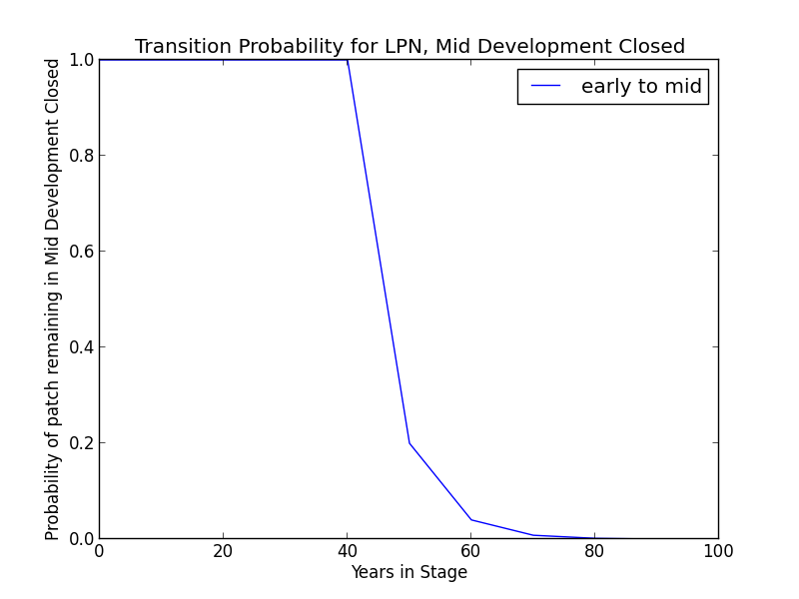A short period of herbaceous productivity precedes closure of the tree canopy on productive sites. The prolific seed output, establishment, and seedling growth of *P. contorta* ssp. *murrayana* makes the period of herbaceous production short (Bartolome 1988) *P. contorta* ssp. *murrayana* regeneration density ranges from moderate to dog hair thickets (LandFire 2007a).

**Succession Transition** In the absence of disturbance, this class will begin transitioning to mid development after 10 years. The probability of succession per time step is 0.8. At 40 years, all stands will have succeeded.

**Wildfire Transition** High mortality wildfire (100% of fires) recycles the patch through the Early Development stage. Low mortality wildfire is not modeled for this stage.

**Mid Development - Open (MDO)**

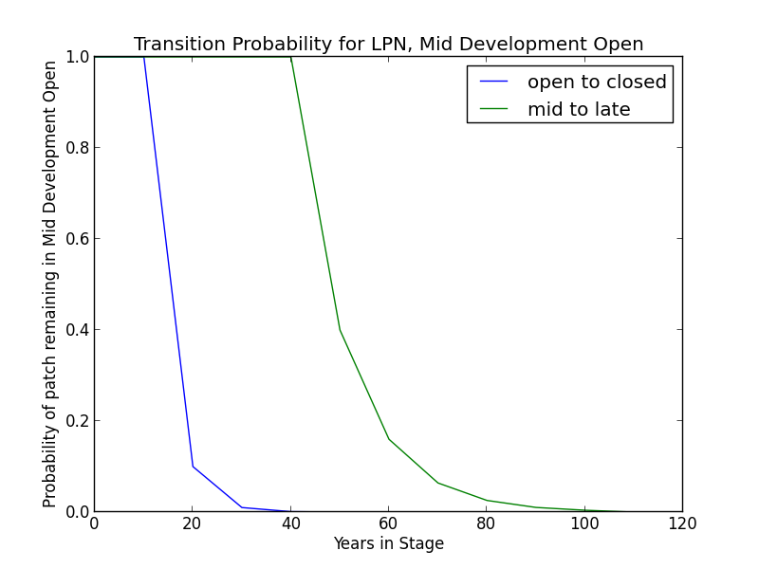

**Description** Sparse ground cover of grasses, forbs, and shrubs. Mid-maturity lodgepole pine where surface fire or other disturbance has opened the stand. Canopy cover ranges from 10-50%

(LandFire 2007a).

Continued recruitment into stands produces overstocking and slow growth of the overcrowded trees. This overcrowding may make them susceptible to insects, although others have argued that the more vigorously growing trees are more likely to be attacked. Beetle infestation creates large quantities of fuel that increase the probability of wildfire (Bartolome 1988).

**Succession Transition** This class will maintain under low mortality disturbance, but after 20 years without fire it begins transitioning to MDC with a probability of 0.9 per time step. Succession to the Late Development stages begin once the age since transition to a mid-development class for that patch is at least 55 years, even if the patch has shifted between open and closed mid development classes. Succession to LDO occurs once the patch has been in mid development for 50 years. The probability of succession per time step is 0.6. After 100 years, all stands will have succeeded.

**Wildfire Transition** High mortality wildfire (7% of fires) recycles the patch through the Early Develop- ment stage. Low mortality wildfire (93%) maintains the patch in MDO.

**Mid Development - Closed (MDC)**

**Description** Sparse ground cover of grasses, forbs, and shrubs; mid-maturity lodgepole pine undergoing intrinsic stand thinning. Considerable surface fuel from tree mortality from previous fire. Canopy cover is greater than 50% (LandFire 2007a).

Continued recruitment into stands produces overstocking and slow growth of the overcrowded trees. This overcrowding may make them susceptible to insects, although others have argued that the more vigorously growing trees are more likely to be attacked. Beetle infestation creates large quantities of fuel that increase the probability of wildfire. (Bartolome 1988).

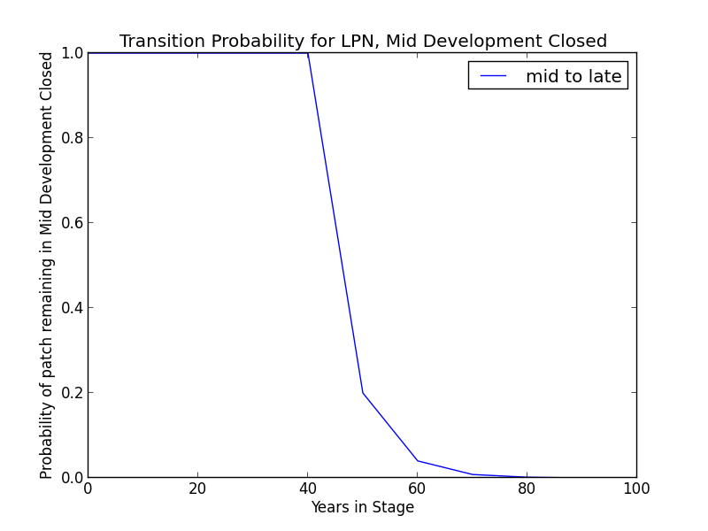

**Succession Transition** After 40 years without a wildfire-triggered transition, this class will begin transitioning to LDC. Patches moving between MDC and MDO begin transitioning after 50 years since transition to mid development. The probability of succession per time step is 0.8. After 80 years, all stands will have succeeded.

**Wildfire Transition** High mortality wildfire (41.7% of fires) recycles the patch through the Early Development stage. Low mortality wildfire (58.3%) triggers a transition to MDO.

**Late Development - Open (LDO)**

**Description** Areas that have experienced one or more low severity understory fires that had reduced stand density or old stands that have not experienced fire but have been thinned by other processes (tree falls etc.). Stands are uneven aged. Canopy cover ranges from 10-50% (LandFire 2007a).

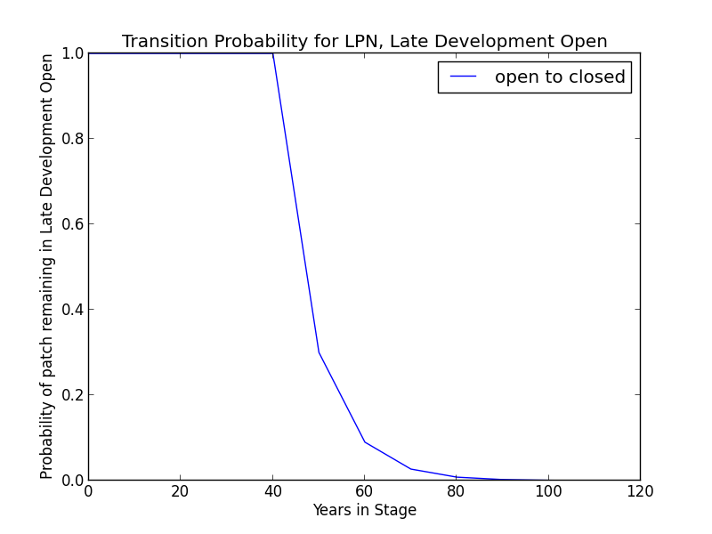**Succession Transition** This class will maintain under low mortality disturbance, but after 50 years without fire, this class succeeds to LDC with a probability per timestep of 0.7.

**Wildfire Transition** High mortality wildfire (7% of fires) recycles the patch through the Early Development stage. Low mortality wildfire (93%) maintains the patch in LDO.

**Late Development - Closed (LDC)**

**Description** Old *P. contorta* ssp. *murrayana* stands where fire has had minimal influence. Canopy cover exceeds 50%.

**Succession Transition** This class will maintain in the absence of disturbance.

**Wildfire Transition** High mortality wildfire (26.3% of fires) recycles the patch through the Early Development stage. Low mortality wildfire (73.7%) maintains the patch in LDC.

**Aspen Variant**

**Early Development – Aspen (ED–A)**

**Description** Grasses, forbs, low shrubs, and sparse to moderate cover of tree seedlings/saplings (primarily *P. tremuloides*) with an open canopy. This condition is characterized by the recruitment of a new cohort of early successional, shade-intolerant tree species into an open area created by a stand-replacing disturbance.

Following disturbance, succession proceeds rapidly from an herbaceous layer to shrubs and trees, which invade together (Verner 1988). *P. tremuloides* suckers over 6ft tall develop within about 10 years (LandFire 2007c).

**Succession Transition** Unless it burns, a patch in the early stage persists for 10 years, at which point it transitions to MD-A.

**Wildfire Transition** High mortality wildfire (100% of fires) recycles the patch through the Early Development – Aspen stage. Low mortality wildfire is not modeled for this stage.

**Mid Development – Aspen (MD–A)**

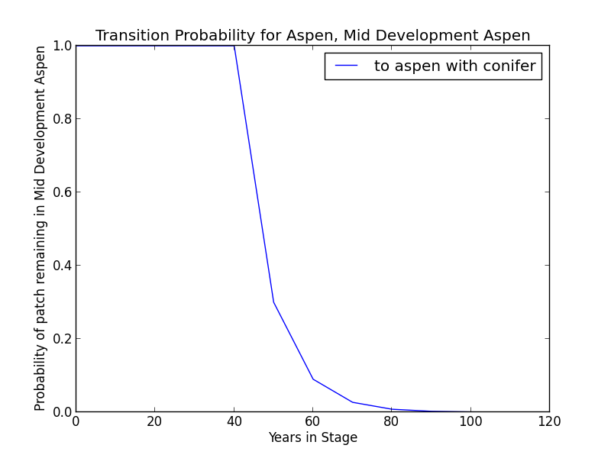**Description** *P. tremuloides* trees 5-16” DBH. Canopy cover is highly variable, and can range from 40-100%. These patches range in age from 10 to 150 years and could maintain indefinitely. Some understory conifers, predominantly *P. contorta* ssp. *murrayana,* are encroaching, but *P. tremuloides* is still the dominant component of the stand (LandFire 2007c).

**Succession Transition** MD-A persists for at least 50 years in the absence of fire, after which stands begin transitioning to MD-AC at a rate of 0.7 per timestep. At age 100 all remaining MD-A patches transition to MD-AC.

**Wildfire** **Transition** High mortality wildfire (100% of fires) recycles the patch through the Early Development – Aspen stage. Low mortality wildfire is not modeled for this stage.

**Mid Development – Aspen with Conifer (MD–AC)**

**Description** These stands have been protected from fire for at least 100 years. *P. tremuloides* trees are predominantly 16” DBH and greater. Conifers (predominantly *P. contorta* ssp. *murrayana*) are present and overtopping the aspen. Conifers are pole to medium-sized, and conifer cover is at least 40% (LandFire 2007c).

**Succession Transition** MD-AC persists for 100 years in the absence of fire, after which stands transition to LDC.

**Wildfire Transition** High mortality wildfire (28.4% of fires) returns the patch to ED-A. Low mortality wildfire (71.6%) maintains the patch in MD- AC.

**Late Development – Closed (LDC)**

**Description** Some *P. tremuloides* continue to be present in the understory, but large *P. contorta* ssp. *murrayana* are now the dominant tree species, having overtopped the *P. tremuloides.* Smaller conifers are present in the midstory as well (LandFire 2007a).

**Succession Transition** This class will maintain in the absence of disturbance.

**Wildfire Transition** High mortality wildfire (31.2% of fires) will return the patch to Early Development - Aspen. Low mortality wildfire (68.8%) maintains the current condition.

**Condition Classification**

Table 2. Classification of cover condition for LPN. Diameter at Breast Height (DBH) and Cover From Above (CFA) values taken from EVeg polygons. DBH categories are: null, 0-0.9”, 1-4.9”, 5-9.9”, 10-19.9”, 20-29.9”, 30”+. CFA categories are null, 0-10%, 10-20%, … , 90-100%. Each row in the table below should be read with a boolean AND across each column of a row.

|  |  |  |  |  |  |
| --- | --- | --- | --- | --- | --- |
| Cover Condition | Overstory Tree  Diameter 1 (DBH) | Overstory Tree  Diameter 2 (DBH) | Total Tree  CFA (%) | Conifer  CFA (%) | Hardwood  CFA (%) |
| Early All | 0-4.9” | any | any | any | any |
| Mid Open | 5-9.9” | any | <50 | any | any |
| Mid Closed | 5-9.9” | any | >50 | any | any |
| Late Open | 10”+ | any | <50 | any | any |
| Late Closed | 10”+ | any | >50 | any | any |

**Draft Models**

See PDF – Disturbance-Succession model for LPN and LPN-ASP

**References**

Bartolome, James W. “Lodgepole Pine (LPN).” *A Guide to Wildlife Habitats of California*, edited by Mayer, Kenneth E. and William F. Laudenslayer. California Deparment of Fish and Game. 1988. <http://www.dfg.ca.gov/biogeodata/cwhr/pdfs/SMC.pdf>. Accessed 4 December 2012.

“CalVeg Zone 1.” Vegetation Descriptions. *Vegetation Classification and Mapping*. 11 December 2008. U.S. Forest Service. <http://www.fs.usda.gov/Internet/FSE_DOCUMENTS/fsbdev3_046448.pdf>. Accessed 2 April 2013.

Cope, Amy B. 1993. “Pinus contorta var. murrayana.” In: Fire Effects Information System, [Online]. U.S. Department of Agriculture, Forest Service, Rocky Mountain Research Station, Fire Sciences Laboratory (Producer). <http://www.fs.fed.us/database/feis/> [Accessed 4 December 2012].

Fites-Kaufman, Jo Ann, Phil Rundel, Nathan Stephenson, and Dave A. Wixelman. “Montane and Subalpine Vegetation of the Sierra Nevada and Cascade Ranges.” In *Terrestrial Vegetation of California, 3rd Edition*, edited by Michael Barbour, Todd Keeler-Wolf, and Allan A. Schoenherr, 456-501. Berkeley and Los Angeles: University of California Press, 2007.

Lotan, James E. and William B. Critchfield. “Lodgepole Pine.” Burns, Russell M. and Barbara H. Honkala, tech. coords. Silvics of North America, vol 1. Conifers; Glossary. Agriculture handbook no.654. Washington, D.C. : U.S. Dept. of Agriculture, Forest Service, 1990.

LandFire. “Biophysical Setting Models.” Biophysical Setting 0610581. 2007a. LANDFIRE Project, U.S. Department of Agriculture, Forest Service; U.S. Department of the Interior. <http://www.landfire.gov/national_veg_models_op2.php>. Accessed 9 November 2012.

LandFire. “Biophysical Setting Models.” Biophysical Setting 0610582. 2007b. LANDFIRE Project, U.S. Department of Agriculture, Forest Service; U.S. Department of the Interior. <http://www.landfire.gov/national_veg_models_op2.php>. Accessed 9 November 2012.

LandFire. “Biophysical Setting Models.” Biophysical Setting 0610610. 2007c. LANDFIRE Project, U.S. Department of Agriculture, Forest Service; U.S. Department of the Interior. <http://www.landfire.gov/national_veg_models_op2.php>. Accessed 7 January 2013.

Skinner, Carl N. and Chang, Chi-Ru. “Fire Regimes, Past and Present.” *Sierra Nevada Ecosystem Project: Final report to Congress, vol. II, Assessments and scientific basis for management options*. Davis: University of California, Centers for Water and Wildland Resources, 1996.

Van de Water, Kip M. and Safford, Hugh D. “A Summary of Fire Frequency Estimates for California Vegetation Before Euro-American Settlement.” *Fire Ecology* 7.3 (2011): 26-57. doi: 10.4996/fireecology.0703026.

Verner, Jared. “Aspen (ASP).” *A Guide to Wildlife Habitats of California*. 1988. Mayer, Kenneth E. and Laudenslayer, William F., eds. California Department of Fish and Game. <http://www.dfg.ca.gov/biogeodata/cwhr/pdfs/SMC.pdf>. Accessed 4 December 2012.